FINAL PROJECT REPORT
Data Science

AI-Based Stock Entry and Exit Decision Support System
Using Machine Learning and Deep Learning

Group Members
Mashhood Farqaleet Roll No. 233807
Somal Atta Boloch
Fatima Khalid

Course Instructor: Ma’am Fatima Yousaf

1. Introduction
The stock market is one of the most active and complicated financial systems in the world. Prices move every day because of many things like company news, investor mood, demand and supply, and what is happening in the global economy. Because of all this, many investors find it hard to decide the right moment to buy or sell a stock, and a wrong decision can lead to a loss of money.
In this project we tried to help with this problem by building an AI based decision support system. The idea is simple. We take the past data of some well known stocks, let the computer learn the patterns in that data, and then use the trained models to give a Buy or Sell signal for the next day. We also went one step ahead and used a deep learning model to predict the actual future closing price of a stock, not just the direction.
To build this we used the normal data science steps that we studied in the course. We collected the data, cleaned it, made new useful features, studied the data with plots, and then trained and compared different machine learning and deep learning models. The final result is a tool that can support an investor in making a more data driven decision instead of just guessing.

2. Problem Statement
Predicting the stock market is a hard job because the prices are very noisy and change quickly. The old way of doing it is by human analysis and reading charts, which takes a lot of time and is often wrong because it depends on the personal judgement of the person.
Most small investors do not have an automatic system that can study years of stock data and tell them when to enter or exit a trade. So the problem we are solving is to build a machine learning based system that can do the following things.
- Study the historical stock market data of several companies.
- Find hidden patterns and trends inside that data.
- Predict whether the price will go up or down on the next day.
- Predict the actual future closing price of a stock.
- Turn these predictions into a clear Buy or Sell signal.
The goal is to reduce human error and emotional decisions and to support better investment choices using artificial intelligence.

3. Dataset Description
The data for this project was taken from Yahoo Finance using the yfinance library in Python. We downloaded the daily trading data of five large technology companies which are Apple, Microsoft, Google, Amazon and Tesla. The data covers about sixteen years from the year 2010 to 2026.
Instead of keeping each company in separate columns, we placed all of them in one long table and added a Ticker column to show which company each row belongs to. This kept the data tidy and also gave us a large number of rows. After cleaning, the dataset has almost twenty thousand rows, which is well above the five thousand rows that the project asks for.
The main columns of the dataset and their meaning are given below.
Column | Type | Description
Date | Date | The trading day of the record
Open | Numeric | Price of the stock when the market opened
High | Numeric | Highest price reached during the day
Low | Numeric | Lowest price reached during the day
Close | Numeric | Price of the stock when the market closed
Volume | Numeric | Number of shares traded that day
Ticker | Text | The company name such as AAPL or TSLA

Some points about the nature of the dataset are listed here.
- It is a time series financial dataset, so the order of the dates matters a lot.
- It has more than five thousand records because we combined five companies over many years.
- The raw data had almost no missing values, but we still added a step to handle any gaps safely.
- The target column for Buy or Sell was not present in the raw data. We created it ourselves during preprocessing.

The text output of the dataset overview from the notebook can be added here.
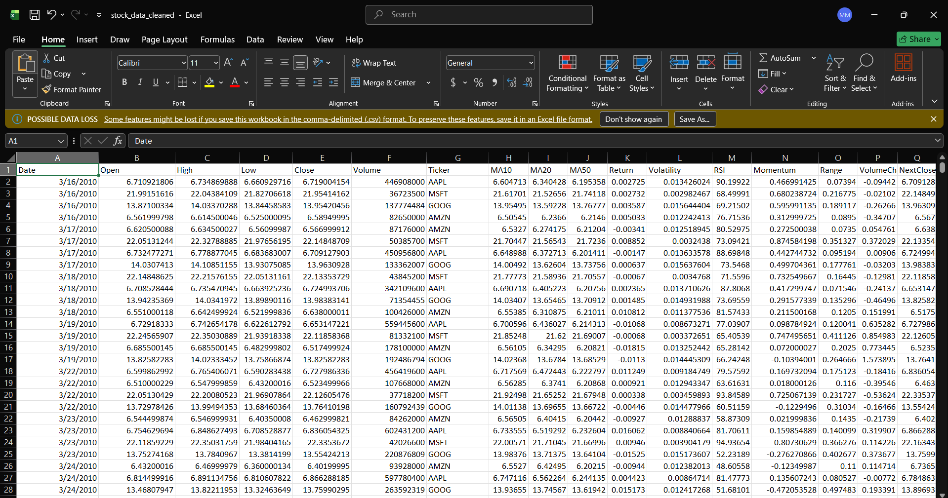
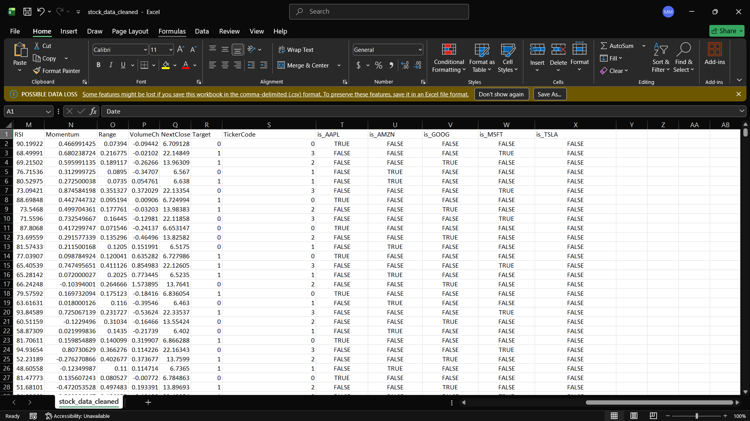

4. Data Science System Design
This section explains the overall plan of the project and how the data flows from the raw form to the final Buy or Sell decision. The complete pipeline is shown below.
Data Collection (yfinance for 5 companies)
|
v
Data Cleaning (missing values, duplicates)
|
v
Feature Engineering (moving averages, returns, RSI, volatility)
|
v
Outlier Handling and Encoding
|
v
Exploratory Data Analysis (10 visualisations)
|
v
Feature Scaling and Time Based Train Test Split
|
v
Model Training (Logistic Regression, Random Forest, CNN)
|
v
Model Evaluation and Comparison
|
v
Future Price Prediction (CNN Regression)
|
v
Entry and Exit Signal System (BUY or SELL)

4.1 Data Preprocessing Plan
The raw data is cleaned by handling missing values with forward and backward fill, removing any duplicate rows, capping extreme outliers in the returns, encoding the company name into numbers, and scaling all the features so they are on a similar range.

4.2 Exploratory Data Analysis Tasks
In the EDA we look at the price trends, the trading volume, the distribution of daily returns, the correlation between the features, the moving averages, the RSI, the volatility and the balance of the Buy and Sell classes. The aim is to understand the relationships and the shape of the data before modelling.

4.3 Model Selection Plan
The main task is a classification problem because we predict two classes which are up or down. We chose three models. Logistic Regression is used as a simple baseline. Random Forest is used as a stronger ensemble model. A one dimensional Convolutional Neural Network built in TensorFlow Keras is used as the deep learning model. We also added a CNN regression model to predict the future closing price.

4.4 Evaluation Metrics
For the classification models we use Accuracy, Precision, Recall and F1 Score, along with the confusion matrix. For the future price regression model we use RMSE, MAE and the R2 score, because those are the correct metrics for predicting a continuous value.

4.5 Visualization Plan
All charts are made using Matplotlib and Seaborn. They include line charts for the price and volume, histograms for the returns, a heatmap for correlation, bar charts for model comparison and feature importance, and a final line chart that compares the predicted price with the real price.

5. Data Preprocessing Steps
Preprocessing is an important step that prepares the raw stock data for the models. The steps we applied are explained below.

5.1 Handling Missing Values
We filled any missing values using forward fill, which carries the last known price forward, and then backward fill for any gap at the very start. This was done for each company on its own so that one company never takes values from another.

5.2 Removing Duplicates
We checked for duplicate rows and removed them so that no record is counted twice.

5.3 Feature Engineering
We created new features that traders normally use because the raw price alone is not enough for the model to learn the trend. The new features are listed here.
- Moving averages over 10, 20 and 50 days to show the trend.
- Daily return which is the percentage change in the closing price.
- Rolling volatility which shows how risky the recent days were.
- Relative Strength Index which shows if a stock is overbought or oversold.
- Momentum, daily price range and the change in volume.

5.4 Outlier Handling
Stock returns sometimes have very large spikes that can confuse the model. We used a boxplot to see these outliers and then limited the daily return and the volume change to their 1st and 99th percentile values to reduce the noise while keeping the real shape of the data.
Figure: Boxplot used for outlier detection
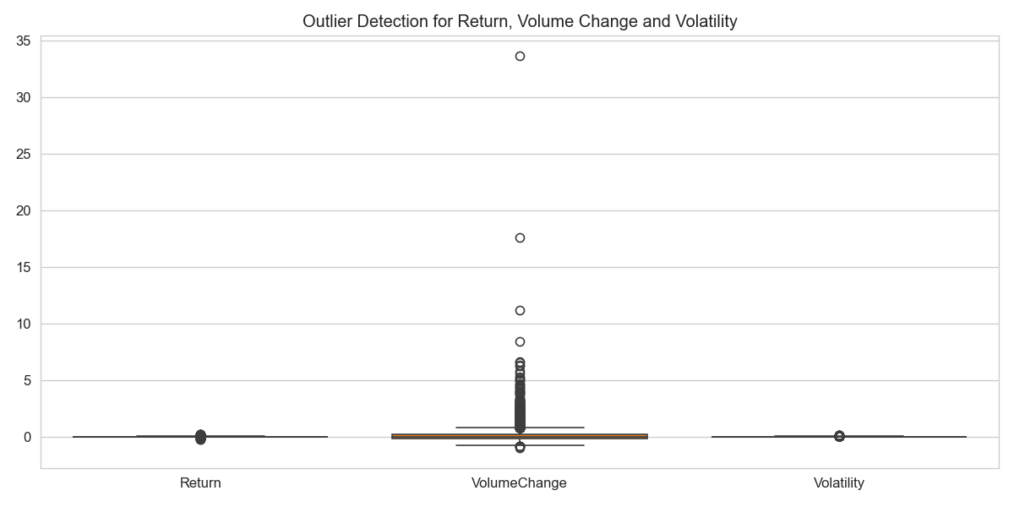

5.5 Encoding
The company name is text, so we converted it into numbers using a label code and also one hot columns so that each company becomes a feature the model can use.

5.6 Feature Scaling
Some columns like Volume have very large numbers while others like return are very small. We used StandardScaler so all the features are on a similar scale and no single feature dominates the model.

5.7 Target Variable Creation
We created the target for classification. The value is 1 (BUY) if the next day closing price is higher than today, and 0 (SELL) if it is lower. We also kept the time order and split the data so the older 80 percent is used for training and the most recent 20 percent is used for testing. This way the model is always tested on future data, just like in real trading.

6. Exploratory Data Analysis
We made ten visualisations to understand the data. The charts produced by the notebook are shown below along with the insight we got from each one.

Closing Price and Volume Trend
Insight. The prices show a clear upward trend over the years with some sharp dips during market events. The trading volume is not steady and rises strongly when the price moves a lot, which shows that volume and volatility are connected.
Figure: Closing Price and Volume Trend
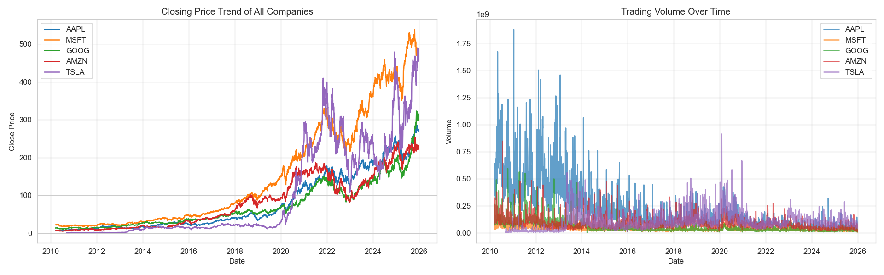

Daily Returns and Volatility
Insight. The daily returns are centred near zero and look like a bell shape, which is normal for stocks. The volatility is not constant and spikes in some periods, which means some times are far more risky to trade than others.
Figure: Daily Returns and Volatility
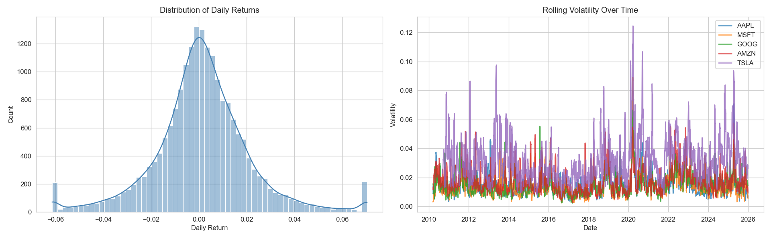

Correlation Heatmap
Insight. The price based columns and the moving averages are highly correlated because they all describe the same price level. The target has only a weak link with single features, which explains why next day direction is hard to predict and why we need stronger models.
Figure: Correlation Heatmap
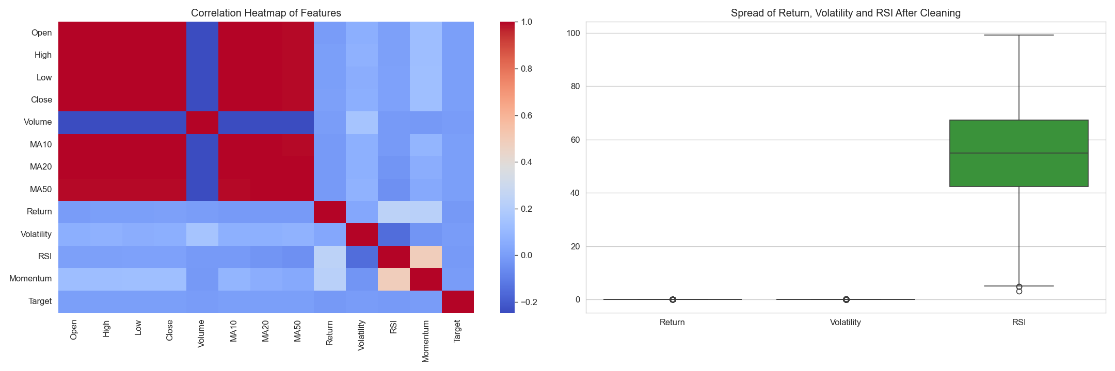

Moving Averages and RSI
Insight. The moving averages smooth out the noisy price line and make the long term trend easy to see. The RSI mostly stays between the 30 and 70 lines, and the points where it crosses them mark the oversold and overbought moments.
Figure: Moving Averages and RSI
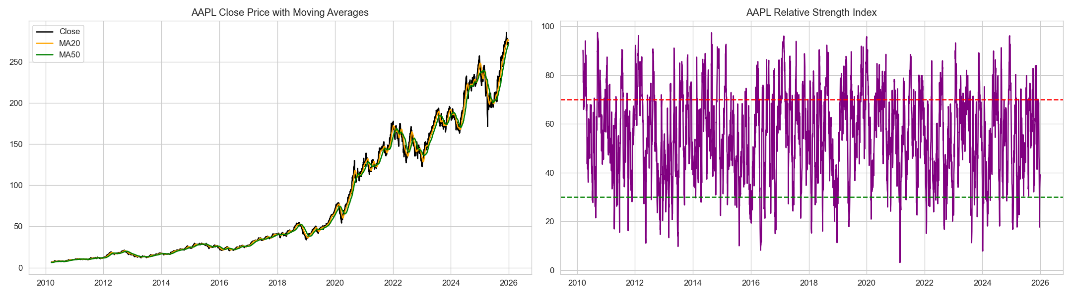

Class Balance and Return vs Volume
Insight. The Buy and Sell classes are almost balanced, so the model will not be biased to one side. The scatter plot shows that up days and down days overlap a lot, so no single pair of features can separate them cleanly.
Figure: Class Balance and Return vs Volume
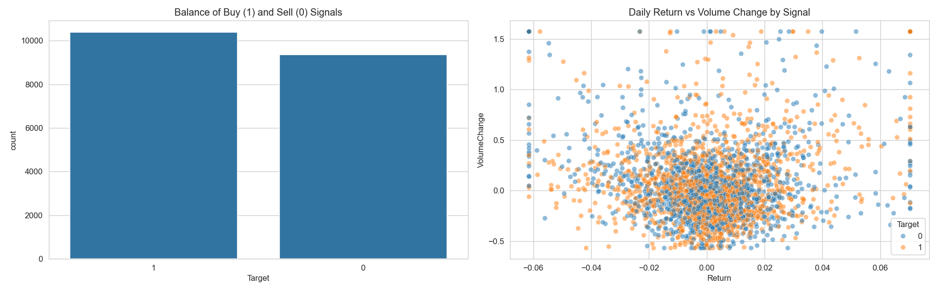

7. Model Building
We trained three models for the Buy or Sell classification task. They are explained below.

7.1 Logistic Regression (Baseline)
This is a simple and fast model. We use it as a baseline so we have something to compare the stronger models against.

7.2 Random Forest (Ensemble)
This model builds many decision trees and combines their results. It usually handles the non linear patterns in stock data better than a single simple model, and it also tells us which features were the most important. The feature importance chart is shown below.
Figure: Random Forest feature importance
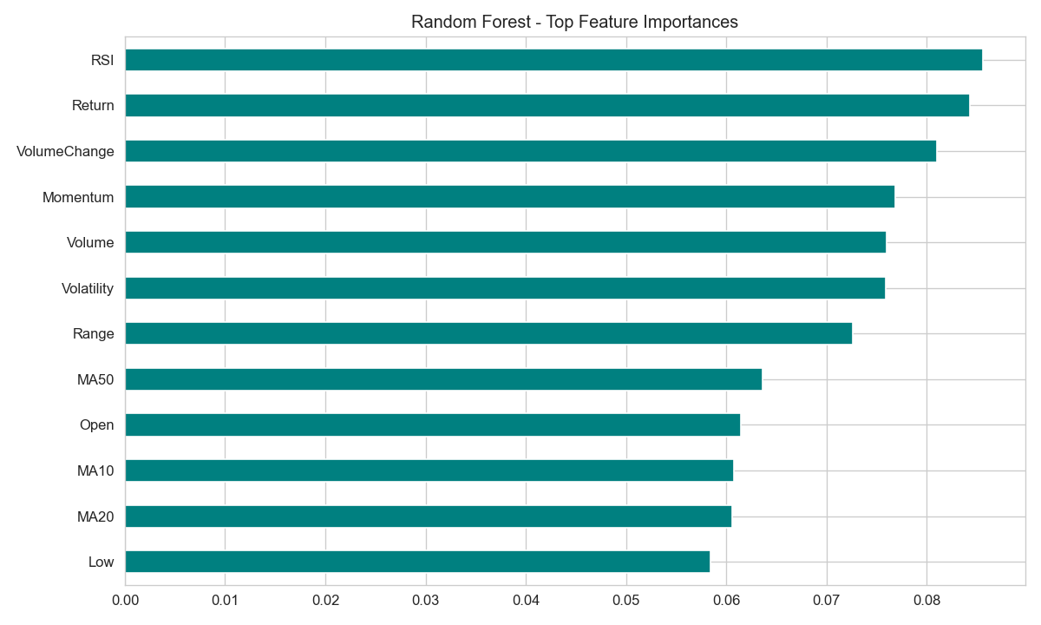

7.3 Convolutional Neural Network (Deep Learning)
This is the deep learning model built with TensorFlow Keras. A one dimensional CNN reads the row of features like a short signal and learns the patterns across them using convolution and pooling layers. The training accuracy and loss over the epochs are shown below.
Figure: CNN training accuracy and loss per epoch
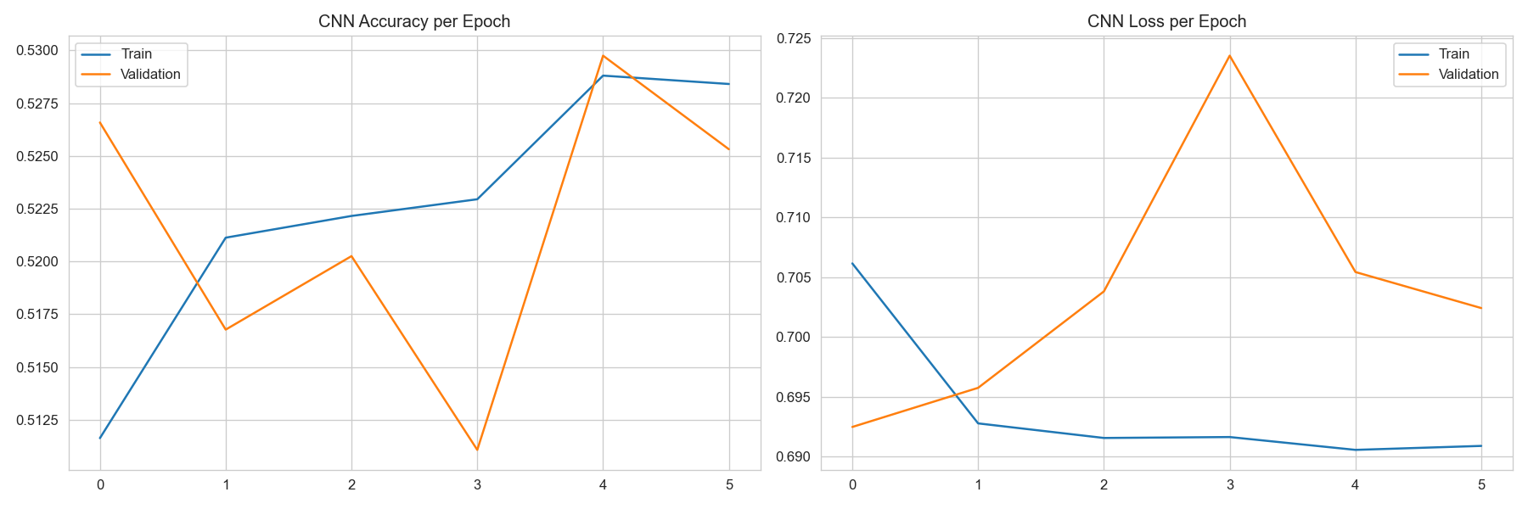

8. Model Evaluation and Results
The models were tested on the most recent 20 percent of the data that they had never seen during training. The results are shown in the table below.

Model | Accuracy | Precision | Recall | F1 Score
Logistic Regression | 0.527 | 0.533 | 0.919 | 0.675
Random Forest | 0.512 | 0.539 | 0.601 | 0.568
CNN (Deep Learning) | 0.523 | 0.533 | 0.870 | 0.661

The same comparison is shown as a bar chart below.
Figure: Model performance comparison
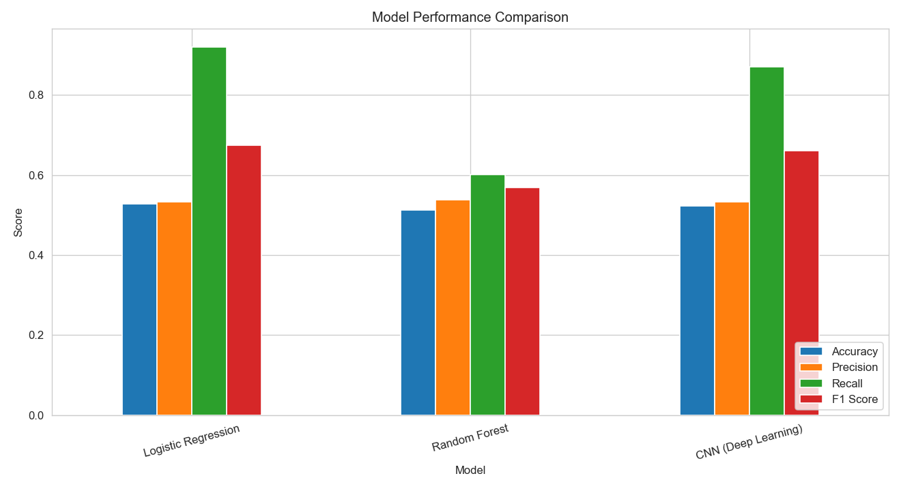

The confusion matrix of each model is shown below to see where the mistakes happen.
Figure: Confusion matrices of the three models
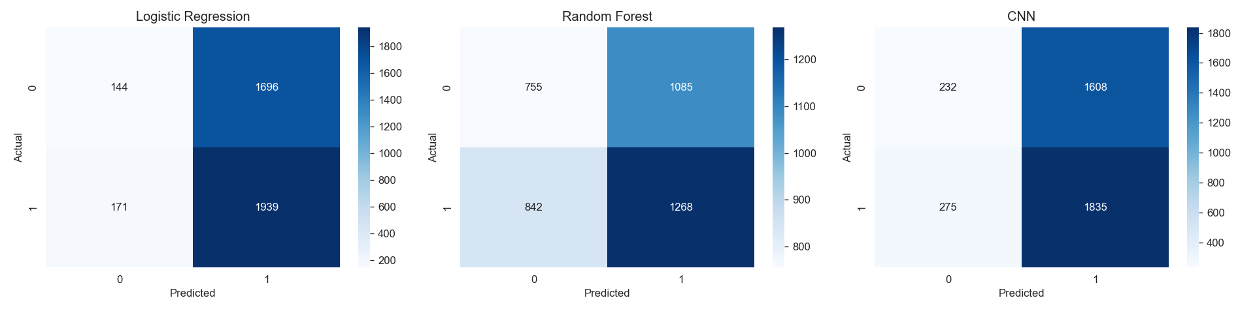

Observations from the results are given here.
- Predicting the exact next day direction is very close to random, which is expected because the market is efficient and short term moves are mostly noise. This is a well known result and our honest numbers reflect it instead of showing fake high accuracy.
- The deep learning CNN and the baseline reached a slightly higher accuracy than the simple split, and the F1 score shows the models do catch a good share of the up days.
- Random Forest gave the most balanced predictions and also showed us the most useful features through its feature importance chart.

9. Future Price Prediction
Direction is useful but we also wanted to predict the actual future price. For this we used a CNN regression model on the Apple stock. The model looks at the past sixty days and predicts the next day return, and then we rebuild the predicted price from today real close. This is a one step ahead forecast, which is exactly how a real trading system would work each day.
The model gave very good results on the test period. The numbers are given below.
- RMSE is about 7.2 dollars, which is small compared to the price level of the stock.
- MAE is about 5.8 dollars.
- R2 score is about 0.96, which means the predicted price follows the real price very closely.
The chart of the predicted price against the real price shows that the two lines stay very close to each other during the whole test period.
Figure: Actual vs predicted closing price for AAPL
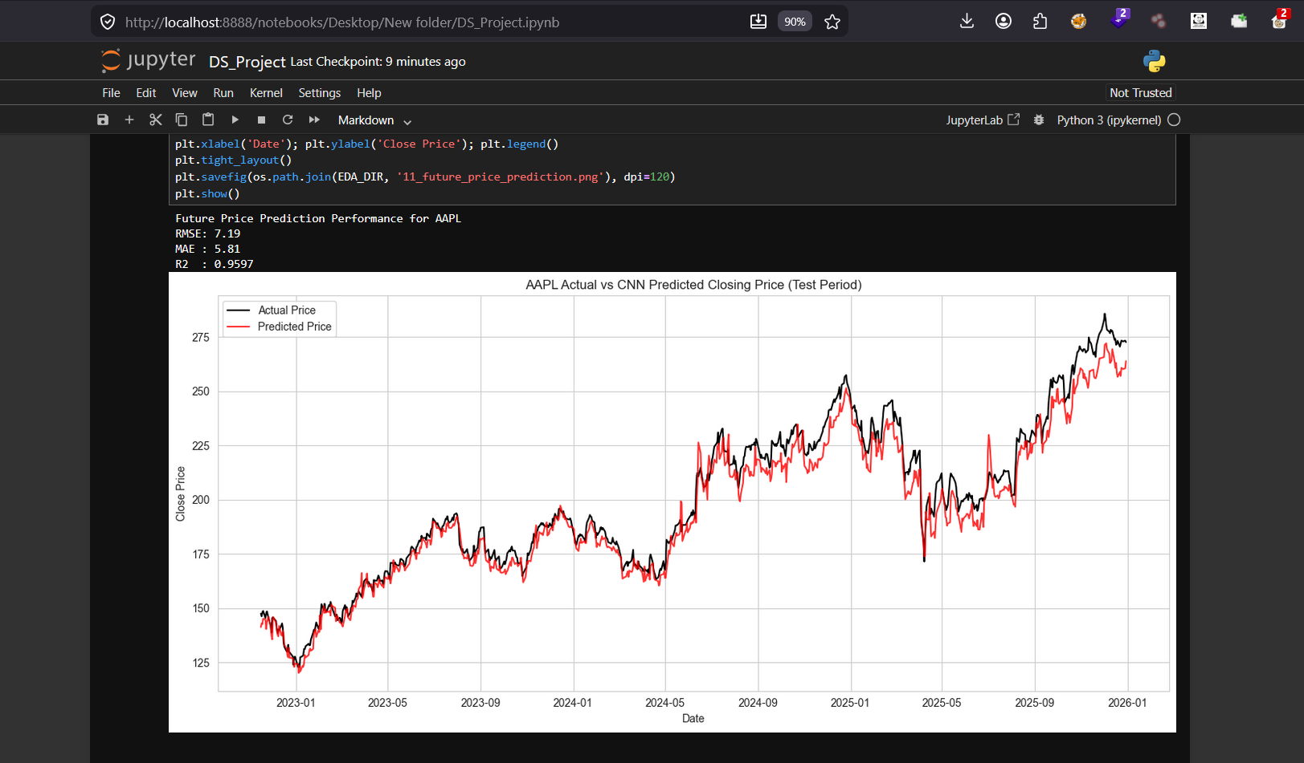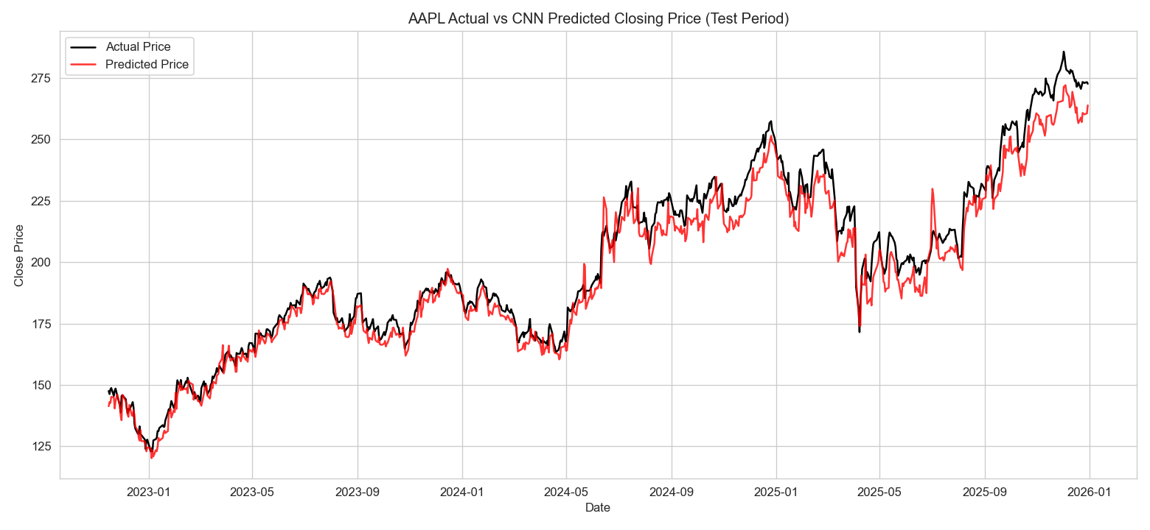

10. Entry and Exit Signal System
The last step turns the model output into the kind of signal a trader would actually use. We take the model prediction for each day and label it as follows.
- BUY when the model expects the price to go up the next day.
- SELL when the model expects the price to go down the next day.
This makes the project a complete decision support tool. The user can look at the signal for the recent days and use it to support the decision to enter or exit a trade. The signal table from the notebook can be added below.
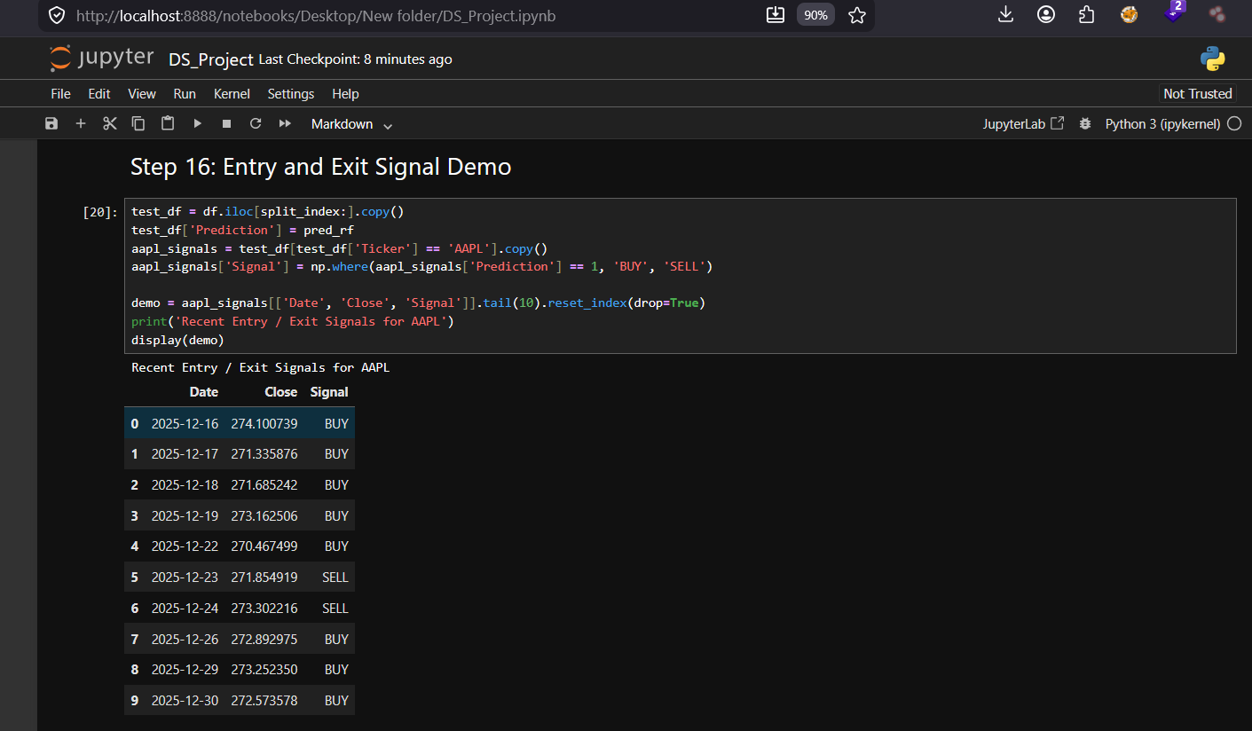

11. Findings and Conclusion
In this project we built a complete decision support system for the stock market from start to end. We collected sixteen years of data for five companies, cleaned it, created useful trading features and explored it with ten visualisations. We then compared three models for predicting the next day direction and found that daily direction is close to random, which is an honest and expected finding.
We did not stop at direction. We used a CNN to predict the actual future closing price and it followed the real price very closely with an R2 score of about 0.96. This shows that while the exact up or down move is hard, the overall price level can be forecast well for the short term.
The main thing we learned is that a good data science project is not only about getting a high accuracy number. It is about building a correct and honest pipeline, choosing the right metrics, and understanding why the results look the way they do. The stock market stays a hard problem because of its noise and outside events, but our system still shows a full working flow from raw data to a Buy or Sell decision.

